Contents

Exploratory data analysis 2

What are the top restaurant chains in Bengaluru? 2

How many of the restaurants do not accept online orders? 2

Rating distribution 3

Cost vs rating 4

Distribution of cost for two people 5

Is there any difference b/w votes of restaurants accepting and not accepting online orders? 6

Which are the most common restaurant type in Bangalore? 7

Cost factor ? 7

Which are the foodie areas? 8

Which are the most common cuisines in each location? 8

Extracting location information using Geopy 9

Heatmap of restaurant count on each location 9

What are the most popular cuisines of Bangalore? 10

Heatmap of North Indian restaurants 10

What about South Indian cuisines? 11

Which are the most popular casual dining restaurant chains? 11

Where are their outlets located? 11

Top quick bites restaurant chains in Bangalore 11

Where are their outlets located? 12

Top Cafes of Bangalore? 12

Where are their outlets located? 13

Analyzing Reviews 13

Rating distribution 15

Visualizing output 16

T-SNE of Reviews 18

T-SNE of adjectives used in positive reviews 20

T-SNE of adjectives used in Negative reviews 22

# Exploratory data analysis

## What are the top restaurant chains in Bengaluru?

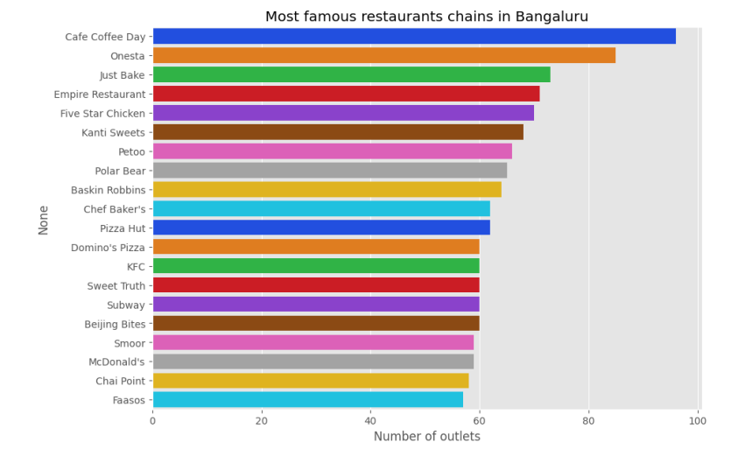

1. As you can see Cafe coffee day, Onesta , Just Bake has the greatest number of outlets in and around Bangalore.

## How many of the restaurants do not accept online orders?

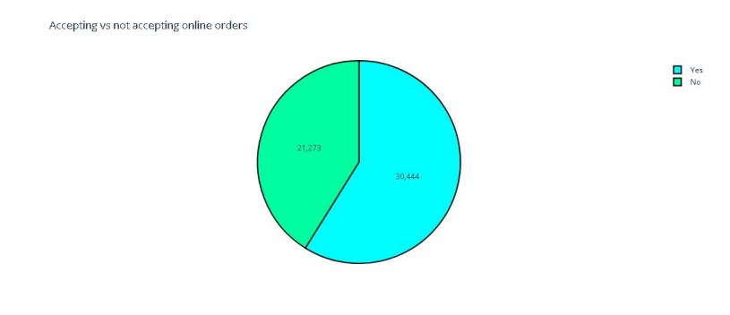

1. As clearly indicated, almost 60 per cent of restaurants in Bangalore accepts online orders.

2. Nearly 40 per cent of the restaurants do not accept online orders.

3. This might be because of the fact that these restaurants cannot afford to pay commission to Zomato for giving them orders online. Zomato may want to consider giving them some more benefits if they want to increase the number of restaurants serving their customers online.

## Rating distribution

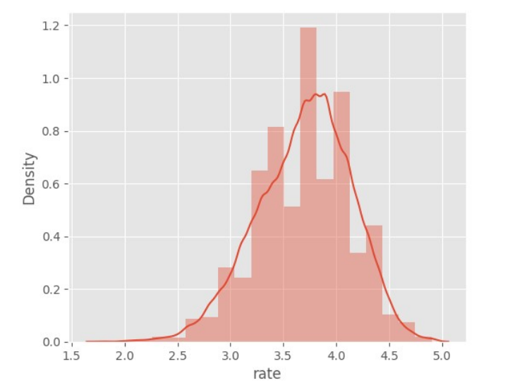

1. Almost more than 50 percent of restaurants has rating between 3 and 4.

2. Restaurants having rating more than 4.5 are very rare.

## Cost vs rating

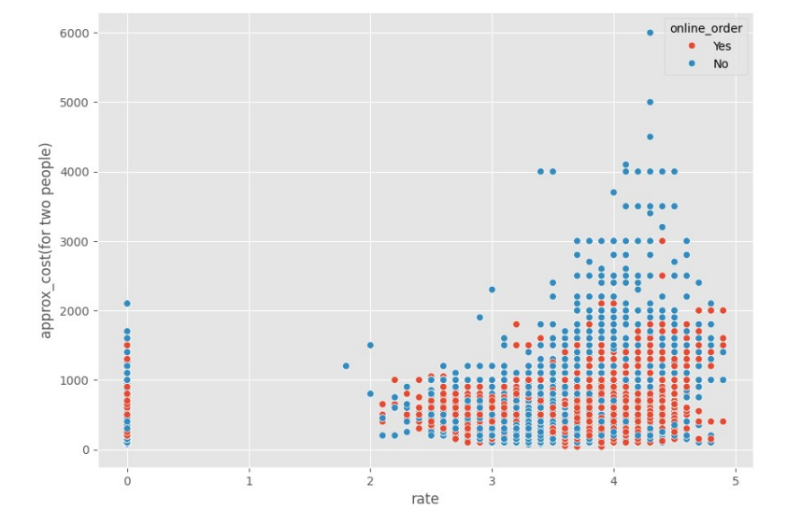

1. **Cost Distribution at Different Ratings**:
   * Restaurants with a rating of 0 have a wide range of costs, up to around 2000 units.
   * For ratings between 2 and 3, costs are generally lower, mostly below 1000 units.
   * Ratings between 3 and 5 show a wider spread in costs, with some restaurants reaching up to 6000 units, but most stay below 3000 units.
2. **Online Ordering**:
   * Both online and non-online ordering restaurants are scattered across all rating levels.
   * At higher rating levels (above 3), there are more restaurants with online ordering (red) compared to lower rating levels.
3. **Cluster Patterns**:
   * There is a noticeable concentration of restaurants with costs around 500 to 2000 units for ratings between 3 and 5.
   * A smaller concentration of lower-cost restaurants is observed around rating levels 0 to 2.

## Distribution of cost for two people

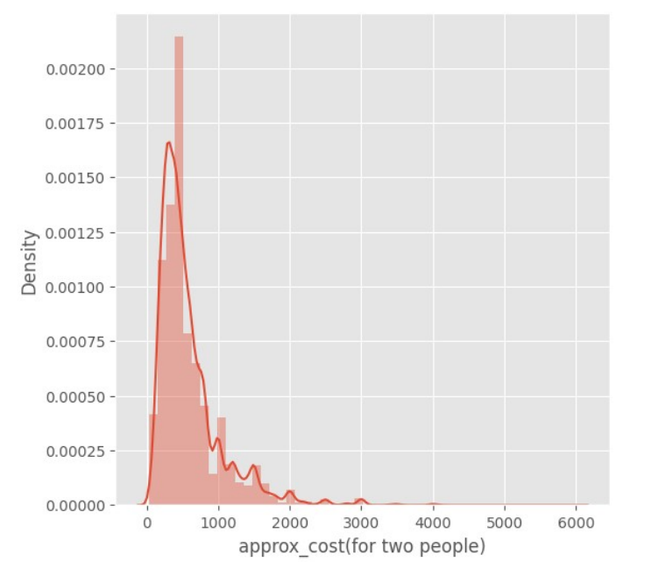

1. We can see that the distribution if left skewed.
2. This means almost 90percent of restaurants serve food for budget less than 1000 INR. ($15)

## Is there any difference b/w votes of restaurants accepting and not accepting online orders?

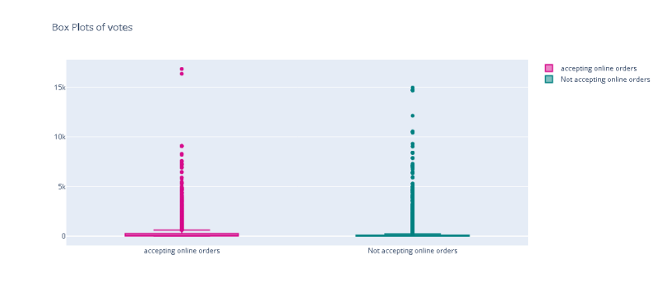

1. Yes, you can observe that median number of votes for both categories vary.

2. Restaurants accepting online orders tend to get more votes from customers as there is a rating option popping up after each order through Zomato application.

## Which are the most common restaurant type in Bangalore?

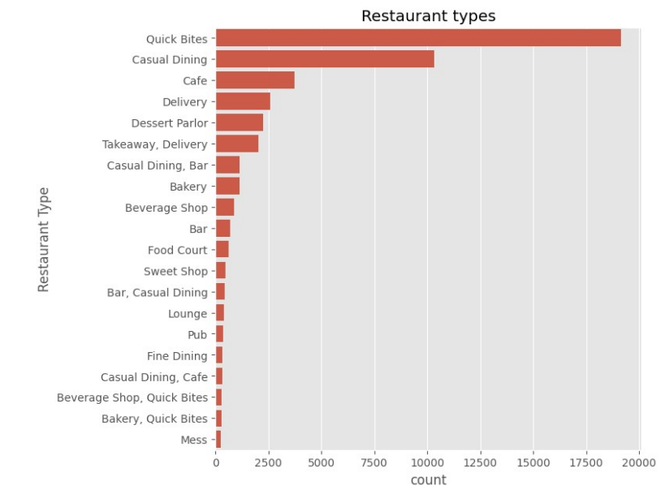

1. No doubt about this as Bangalore is known as the tech capital of India, people having busy and modern life will prefer Quick Bites.

2. We can observe that Quick Bites type restaurants dominates.

## Cost factor ?

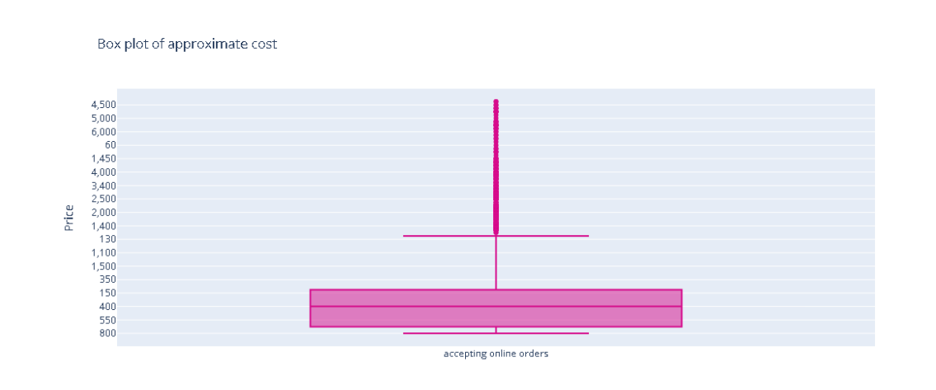

1. The median approximate cost for two people is 400 for a single meal.

2. 50 percent of restaurants charge between 300 and 650 for single meal for two people.

## Which are the foodie areas?

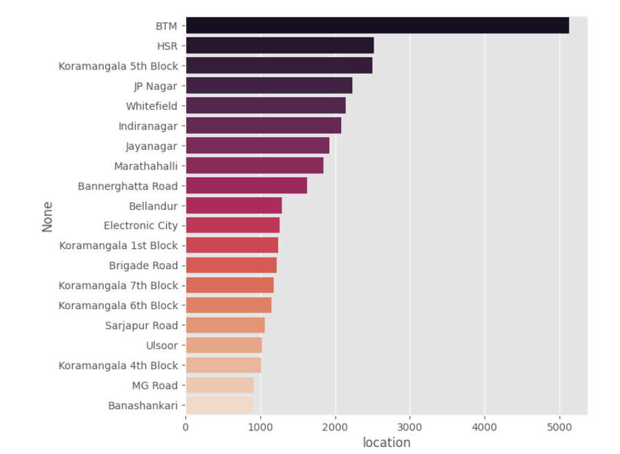

1. We can see that BTM,HSR and Koramangala 5th block has the greatest number of restaurants.

2. BTM dominates the section by having more than 5000 restaurants.

## Which are the most common cuisines in each location?

|  |  |  |  |
| --- | --- | --- | --- |
| level_0 | location | cuisines | count |
| 0 | BTM North | Indian, Chinese | 379 |
| 0 | BTM North | North Indian | 340 |
| 0 | BTM | Biryani | 120 |
| 1 | Banashankari | South Indian | 86 |
| 1 | Banashankari | North Indian, Chinese | 61 |
| 1 | Banashankari | North Indian | 36 |
| 2 | Banaswadi | South Indian | 37 |
| 2 | Banaswadi | North Indian, Chinese | 24 |
| 2 | Banaswadi | Biryani | 23 |
| 3 | Bannerghatta Road | North Indian, Chinese | 130 |

certain locations have a higher concentration of specific cuisines. For instance, North Indian and Chinese cuisines are particularly popular in BTM and Bannerghatta Road, while South Indian cuisine is most common in Banashankari and Banaswadi.

## Extracting location information using Geopy

|  |  |  |
| --- | --- | --- |
| SL NO | Name | geo_loc |
| 0 | Banashankari | (12.9393328, 77.5539819) |
| 1 | Basavanagudi | (12.9417261, 77.5755021) |
| 2 | Mysore Road | (12.3974397, 76.6691493) |
| 3 | Jayanagar | (12.9418488, 77.5868976) |
| 4 | Kumaraswamy Layout | (12.9067683, 77.5595021) |

We have found out latitude and longitude of each location listed in the dataset using geopy. This is used to plot maps

## Heatmap of restaurant count on each location

1. It is clear that restaurants tend to concentrate in central Bangalore area.

2. The clutter of restaurants lowers are we move away from central.

3. So, potential restaurant entrepreneurs can refer this and find out good locations for their

Venture

## What are the most popular cuisines of Bangalore?

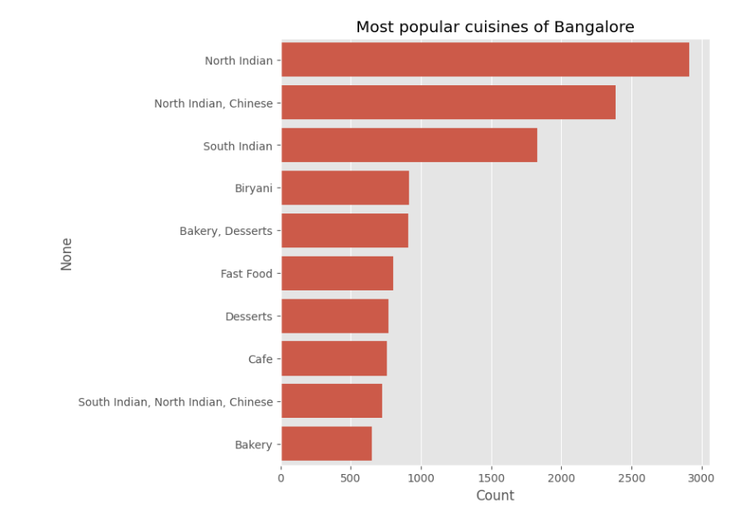

1. We can observe that North Indian, Chinese, South Indian and Biriyani are most common.

2. Is this imply the fact that Bangalore is more influenced by North Indian culture more than

South?

• We will inspect further......

Heatmap of North Indian restaurants

|  |  |  |
| --- | --- | --- |
|  | Name | count |
| 0 | BTM | 340 |
| 1 | Banashankari | 36 |
| 2 | Banaswadi | 12 |
| 3 | Bannerghatta Road | 75 |
| 4 | Basavanagudi1 | 21 |

1. Interesting to see a cluster of North Indian Restaurants in South Bangalore area !

2. This may indicate that these areas are more populated by North Indians.

## What about South Indian cuisines?

|  |  |  |
| --- | --- | --- |
| 0 | Name | count |
| 0 | BTM | 13 |
| 1 | Banashankari | 86 |
| 2 | Banaswadi | 37 |
| 3 | Bannerghatta Road | 48 |
| 4 | Basavanagudi1 | 89 |

1. They tend to span all over Bangalore.

2. South Indian cuisines tend to cluster near central Bangalore

## Which are the most popular casual dining restaurant chains?

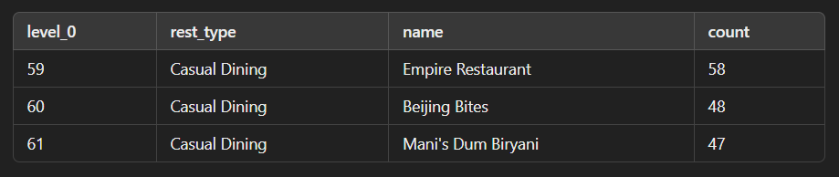

We can see that Empire restaurant, Beijing bites and Mani's dum biriyani are the most popular casual dining restaurant chains in Bangalore.

• We will inspect them further...

## Where are their outlets located?

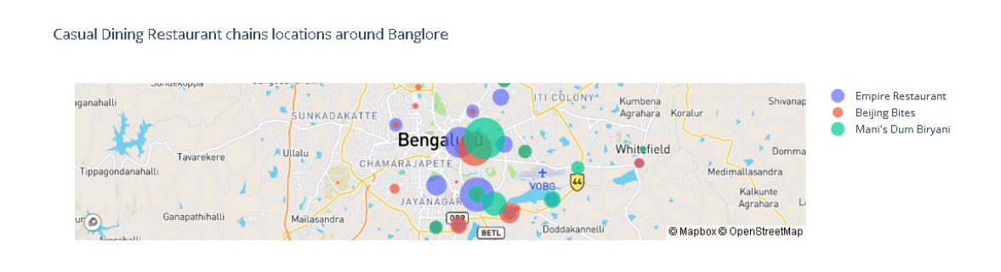

1. We can see that Mani's dum biriyani restaurant has half of their restaurants in central Bangalore.

2. Empire Restaurant is present in all over Bangalore.

3. Mani's dum Biriyani has 12 outlets in Ulsoor, which is the most in a single location.

## Top quick bites restaurant chains in Bangalore

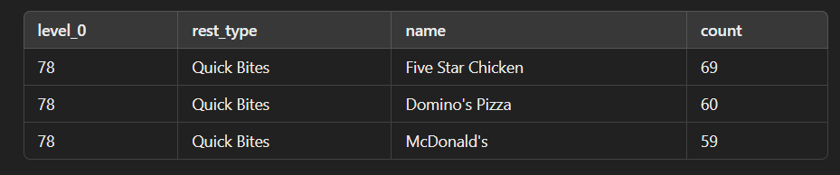

Surprisingly Five star chicken dominates in quick bites restaurant types overtaking famous Domino's Pizza and McDonald's.

• Five Star Chicken is a branch of Charoen Pokphand Group Foods, a Thai multinational conglomerate with over $12 billion business in Agro and Food Industries.

Five Star Chicken specialties in fried chicken.

## Where are their outlets located?

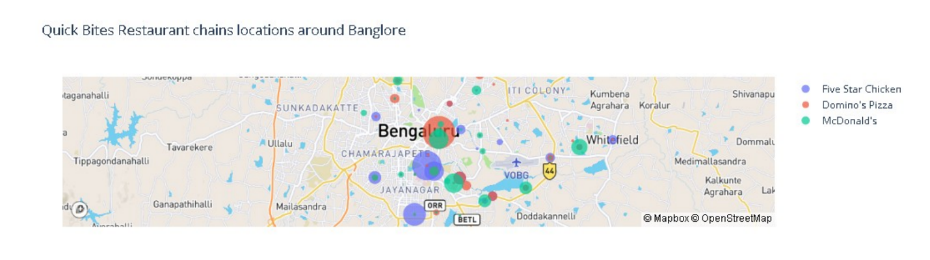

Five Star Chicken (blue) appears to be more widely distributed across the map compared to the other two chains. Domino's Pizza (red) and McDonald's (green) also have several locations, but their clusters are denser in specific areas rather than being spread out evenly.

## Top Cafes of Bangalore?

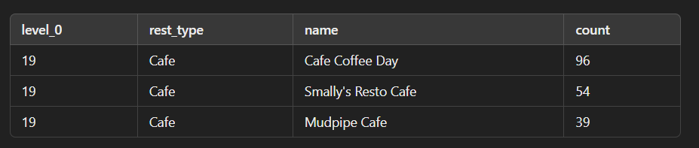

No surprises, Cafe coffee day restaurant dominated way over other cafe chains in Bangalore.

• Cafe coffee day has 96 outlets in Bangalore.

• Café Coffee Day was started as a retail restaurant in 1996. The first CCD outlet was set up on July 11, 1996, at Brigade Road, Bengaluru, Karnataka.

## Where are their outlets located?

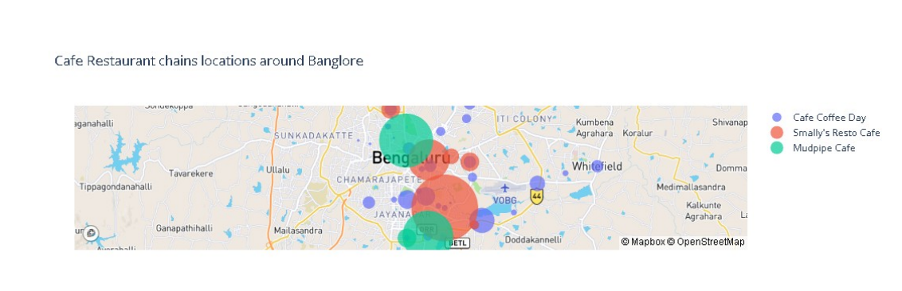

Cafe Coffee Day (blue): The blue dots are spread out across various parts of Bangalore, indicating a wide distribution of this cafe chain.

Smally's Resto Cafe (red): The red dots are highly concentrated in the central region of Bangalore, suggesting that this cafe chain has a strong presence in that particular area.

Mudpipe Cafe (green): The green dots are also concentrated but seem to be located more towards the outskirts of the central area, showing a different distribution pattern compared to the other two chains.

Areas with fewer dots from any cafe chain might represent potential opportunities for expansion, where the demand for cafes could be high but the current supply is low.

The visualization helps in understanding customer accessibility to different cafe chains across Bangalore. For instance, customers in the central regions have access to all three chains, while those on the outskirts might have access to only one or two.

## Analyzing Reviews

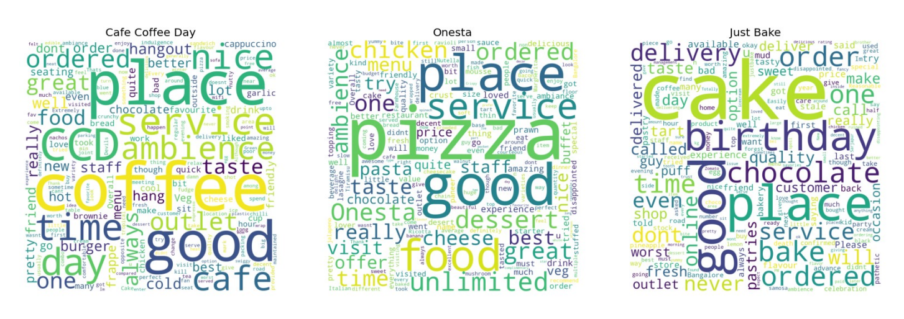

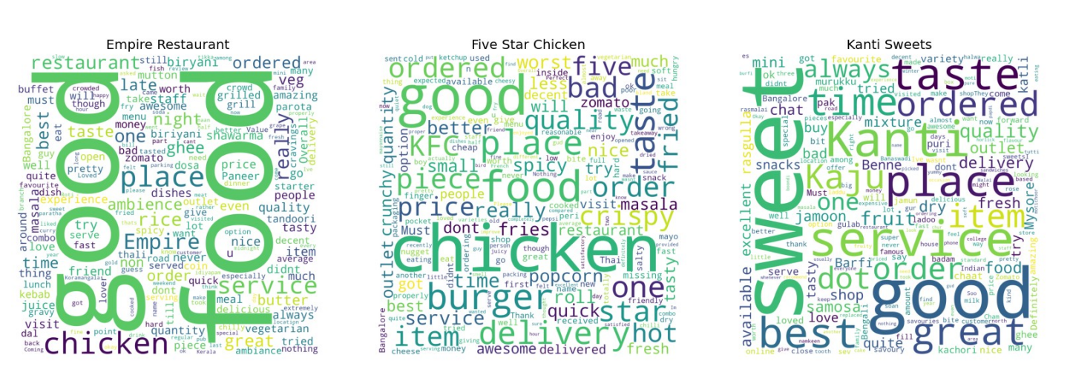

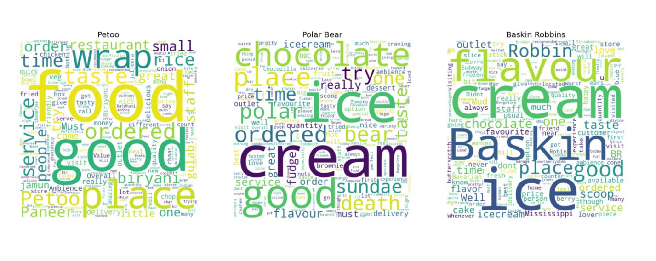

## Rating distribution

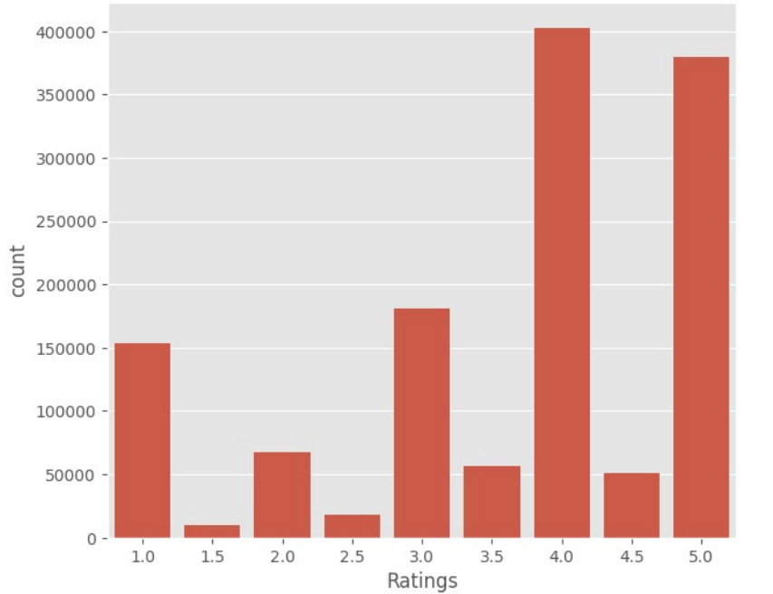

High Ratings: Ratings of 4.0 and 5.0 are the most common, with 4.0 being the highest. This suggests that the majority of users gave high ratings. The high counts for ratings of 4.0 and 5.0 imply general satisfaction or positive experiences among the users.

Low Ratings: There is a significant count for the 1.0 rating, indicating that a notable number of users were very dissatisfied. The significant count for the 1.0 rating could indicate that there is a notable group of users who had very negative experiences, potentially pointing to issues that need to be addressed.

Middle Ratings: Ratings in the middle range (2.0, 3.0) have considerably lower counts, suggesting fewer users felt neutral about their experience.The low counts for intermediate ratings (1.5, 2.5, 3.5) suggest that users tend to rate their experiences in more polarizing terms, either very positively or very negatively, rather than moderately.

## Visualizing output

**Word Counts of Topic Keywords**

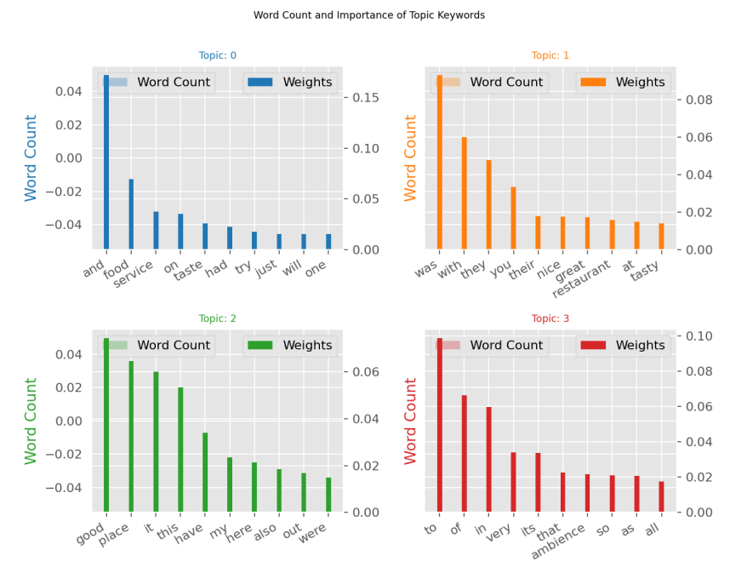

The chart presents the word count and importance (weights) of keywords for four topics.

Positive Sentiments: Words like "nice," "great," "good," and "tasty" indicate overall positive sentiments across different topics.

General Experiences: Common words such as "food," "service," and "ambience" show a focus on the quality and experience provided by the restaurant.

Customer Feedback: The diversity in keywords suggests that customers provide detailed feedback touching on various elements, from food quality to the atmosphere and service.

These insights can help in understanding what aspects are most discussed and valued by customers, aiding in targeted improvements and marketing strategies.

**Topic modeling for negative comments**

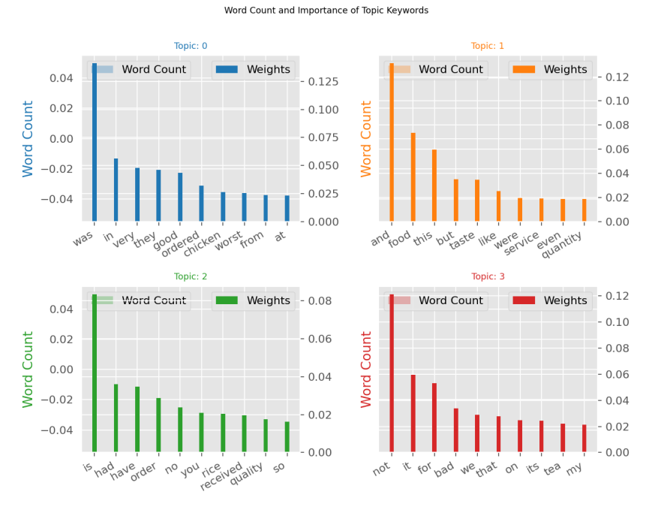

We can clearly observe the difference between the two types of comments

• The words used are clearly distinguishable.

• The words used in negative comments are clearly criticizing.

• The word used in positive comments are clearly appreciating.

Experience-Based Feedback: Topics 0 and 2 highlight specific experiences with orders and food items, suggesting detailed feedback on particular aspects of dining.

Quality and Service: Topic 1 emphasizes overall food quality and service, with mixed sentiments as indicated by words like "taste" and "but."

Negative Sentiments: Topic 3 focuses on negative feedback, highlighting areas of dissatisfaction.

Detailed Reviews: The presence of specific items and personal pronouns suggests that reviews provide detailed and personal accounts of dining experiences.

These insights can help in understanding customer feedback more comprehensively, identifying both positive and negative aspects of the dining experience, and pinpointing specific areas for improvement.

## T-SNE of Reviews

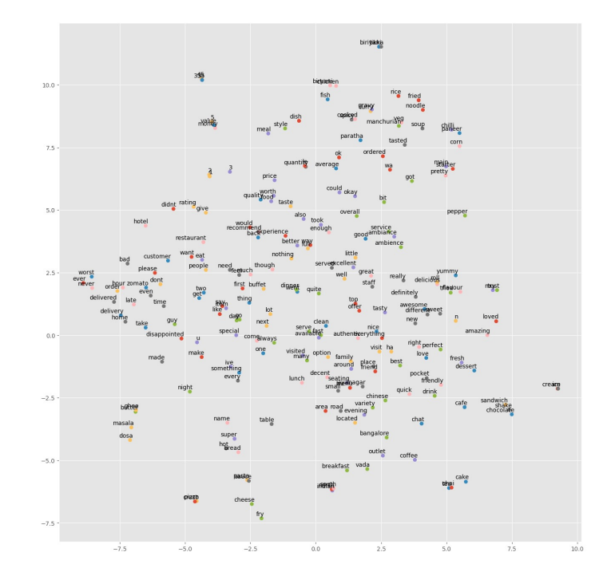

Key Observations:

Clusters of Related Words:

* Top Center (Positive Feedback on Specific Items): Keywords such as "biryani," "paratha," "tasty," "amazing," "perfect," and "yummy" are clustered together, indicating positive feedback on specific dishes.
* Center (General Positive Feedback): Words like "great," "nice," "service," "quality," and "ambience" are clustered, showing overall positive sentiments about the dining experience.
* Bottom Center (Neutral Feedback): Keywords like "decent," "good," "okay," and "average" are grouped, indicating neutral or moderately positive feedback.
* Bottom Left (Negative Feedback): Words such as "worst," "bad," "disappointed," and "not" are clustered, highlighting negative reviews and dissatisfaction.

Frequency and Context:

The plot shows how frequently certain words appear in similar contexts. For example, words like "service," "ambience," and "quality" are positioned close to each other, suggesting they are often mentioned together in reviews.

* Specific food items like "biryani," "paratha," "noodles," and "soup" are clustered, indicating that these items are commonly discussed.
* Diverse Feedback Areas: Keywords related to service (e.g., "service," "staff," "friendly"), food quality (e.g., "tasty," "delicious," "amazing"), and specific dishes (e.g., "biryani," "paratha") highlight different aspects of the dining experience that customers focus on.
* Sentiment Distribution: Positive sentiments (e.g., "great," "amazing," "perfect") are spread across the top and center-right areas, while negative sentiments (e.g., "worst," "bad," "disappointed") are concentrated towards the bottom-left.

Insights:

* Positive Feedback: There is a significant amount of positive feedback focused on specific food items and overall service quality.
* Negative Feedback: While less frequent, negative feedback clusters are clearly identifiable, indicating specific areas of dissatisfaction that can be targeted for improvement.
* General Sentiments: The central cluster of neutral feedback suggests that while many customers have positive experiences, there is room for improvement to turn neutral experiences into positive ones.

This scatter plot can help identify key areas to maintain and improve, ensuring a balanced and comprehensive approach to enhancing customer satisfaction.

# T-SNE of adjectives used in positive reviews

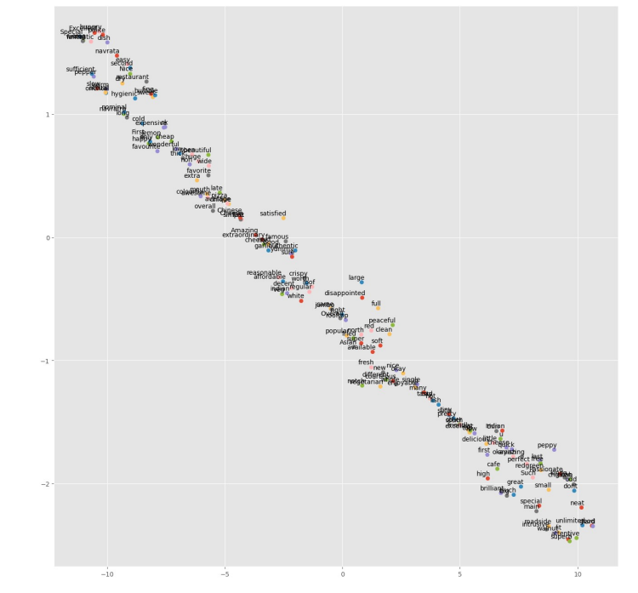

Key Observations:

Diagonal Distribution: The keywords are distributed along a diagonal line, indicating a gradient from negative to positive sentiments or from general to specific topics.

Clusters of Related Words:

* Top Left (Negative Feedback): Keywords like "rude," "worst," "horrible," and "bad" are clustered, suggesting strongly negative feedback.
* Center (Neutral/Mixed Feedback): Words like "satisfied," "okay," "decent," and "average" are positioned around the center, indicating neutral or mixed feedback.
* Bottom Right (Positive Feedback): Keywords such as "delicious," "perfect," "amazing," and "best" are clustered, indicating highly positive feedback.

Specific Experiences and Attributes:

* Top Left: Keywords associated with poor experiences, such as "rude" and "worst," are found here, indicating areas of major dissatisfaction.
* Center: Words like "reasonable," "crispy," and "fresh" suggest specific attributes that are neither overly praised nor criticized, reflecting moderate satisfaction.
* Bottom Right: Positive attributes like "delicious," "perfect," and "amazing" highlight aspects that customers particularly enjoyed.

Diverse Feedback Areas:

The plot shows how frequently certain words appear in similar contexts. For example, positive words tend to group together, as do negative ones, showing distinct areas of customer satisfaction and dissatisfaction.

Specific food items and descriptors like "fresh," "crispy," and "delicious" indicate detailed feedback on particular aspects of the dining experience.

Insights:

* Negative Feedback: The top left cluster of negative keywords highlights critical areas needing improvement, such as service quality and specific bad experiences.
* Neutral Feedback: The central cluster of neutral or mixed feedback suggests that while some customers have moderate experiences, these areas have the potential for improvement to enhance overall satisfaction.
* Positive Feedback: The bottom right cluster of positive keywords shows what aspects customers appreciate the most, providing a focus for maintaining and promoting these strengths.

This scatter plot provides a comprehensive view of customer feedback, showcasing a gradient from negative to positive sentiments and highlighting specific areas of satisfaction and dissatisfaction. This can help in identifying key areas for improvement and ensuring a balanced approach to enhancing customer experiences.

T-SNE of adjectives used in Negative reviews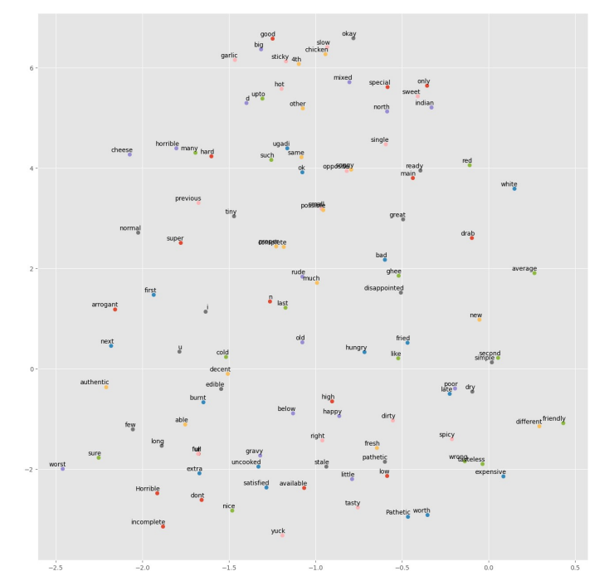

Key Observations:

**Clusters of Related Words:**

* Top Left (Negative Experiences):Keywords like "horrible," "cheese," and "hard" suggest strongly negative experiences, possibly with specific food items.
* Top Center (Neutral/Mixed Feedback): Words like "good," "big," "slow," "chicken," and "okay" are present, indicating a mix of sentiments with some positive and some negative connotations.
* Center Right (Positive Feedback): Keywords such as "great," "good," "ready," "only," and "special" indicate more positive feedback about certain aspects or items.
* Bottom Left (Strong Negative Feedback):Words like "worst," "horrible," "burnt," "old," and "cold" indicate severe dissatisfaction and poor experiences.
* Bottom Right (Neutral/Negative Feedback): Words like "expensive," "worth," "pathetic," and "dirty" show mixed but generally negative sentiments.

Specific Experiences and Attributes:

* Negative Feedback: Keywords like "horrible," "worst," "burnt," "cold," and "stale" highlight areas of major dissatisfaction, likely related to food quality.
* Mixed Feedback: Keywords such as "good," "big," "slow," "okay," and "mixed" suggest a range of experiences that are not strongly positive or negative.
* Positive Feedback: Words like "great," "good," and "ready" highlight positive aspects and satisfactory experiences.

Diverse Feedback Areas: The plot shows how frequently certain words appear in similar contexts, with specific clusters indicating focused areas of customer feedback. For example, the top right area shows positive feedback on food and service, while the bottom left area highlights severe complaints.

Insights:

* Negative Feedback: There are strong clusters of negative keywords indicating significant areas needing improvement, particularly in food quality (e.g., "horrible," "cold," "stale").
* Neutral/Mixed Feedback: Central clusters of mixed keywords suggest areas where customer experiences are varied, indicating potential areas for focused improvement to turn neutral experiences into positive ones.
* Positive Feedback: Clusters of positive keywords suggest areas that customers appreciate and are satisfied with, which can be maintained and promoted.

This scatter plot provides a comprehensive view of customer feedback, showcasing specific areas of satisfaction and dissatisfaction. It helps in identifying key areas for improvement and ensuring a balanced approach to enhancing customer experiences.

# SENTIMENTAL ANALYSIS

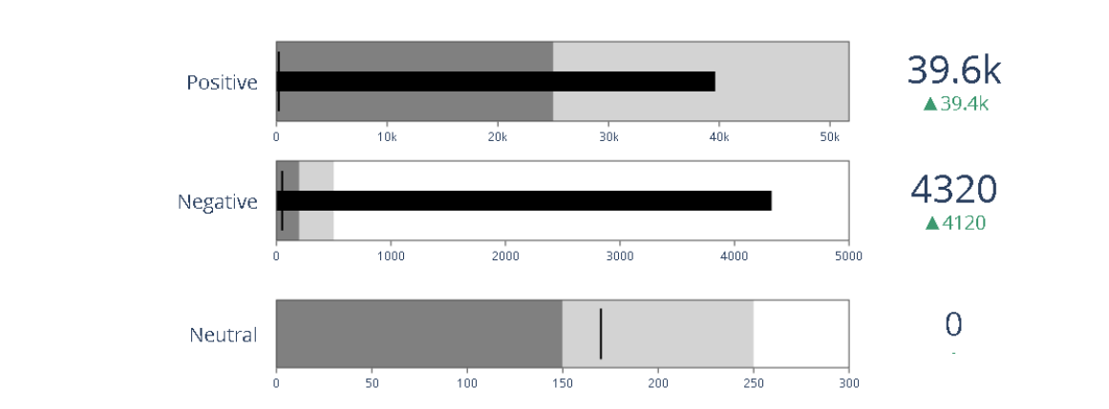

Positive:

* The bar shows a value of 39.6k, consistent with the value=39629 in the code.
* The green indicator shows an increase (delta) of 39.4k, which aligns with the large increase in positive reviews.
* The gauge range is from 0 to approximately 50k, with steps colored gray and light gray.

Negative:

* The bar shows a value of 4320, closely matching the value=4324 in the code.
* The green indicator shows an increase (delta) of 4120, indicating a significant rise in negative reviews.
* The gauge range is from 0 to approximately 5000, with steps colored gray and light gray.

Neutral:

* The bar shows a value of 0, consistent with the value=0 in the code.
* There is no increase, matching the lack of neutral reviews.
* The gauge range is from 0 to approximately 300, with steps colored gray and light gray.

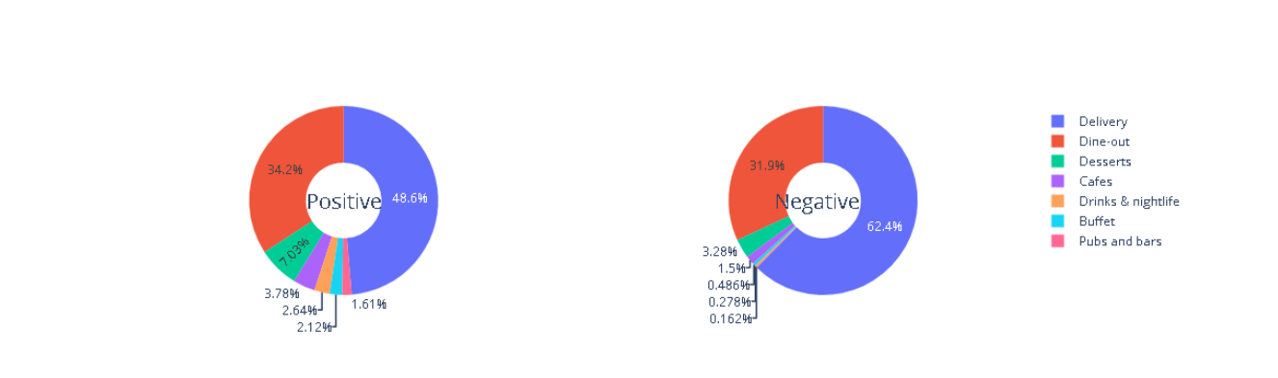

Positive Reviews:

* The largest segment of positive reviews (48.6%) is for Delivery services.
* Dine-out also has a significant proportion of positive reviews (34.2%).
* Desserts, Cafes, Drinks & nightlife, Buffet, and Pubs and bars have smaller shares of positive reviews.

Negative Reviews:

* Delivery has the highest proportion of negative reviews (62.4%).
* Dine-out follows with 31.9% of negative reviews.
* Desserts, Cafes, Drinks & nightlife, Buffet, and Pubs and bars have relatively small shares of negative reviews.

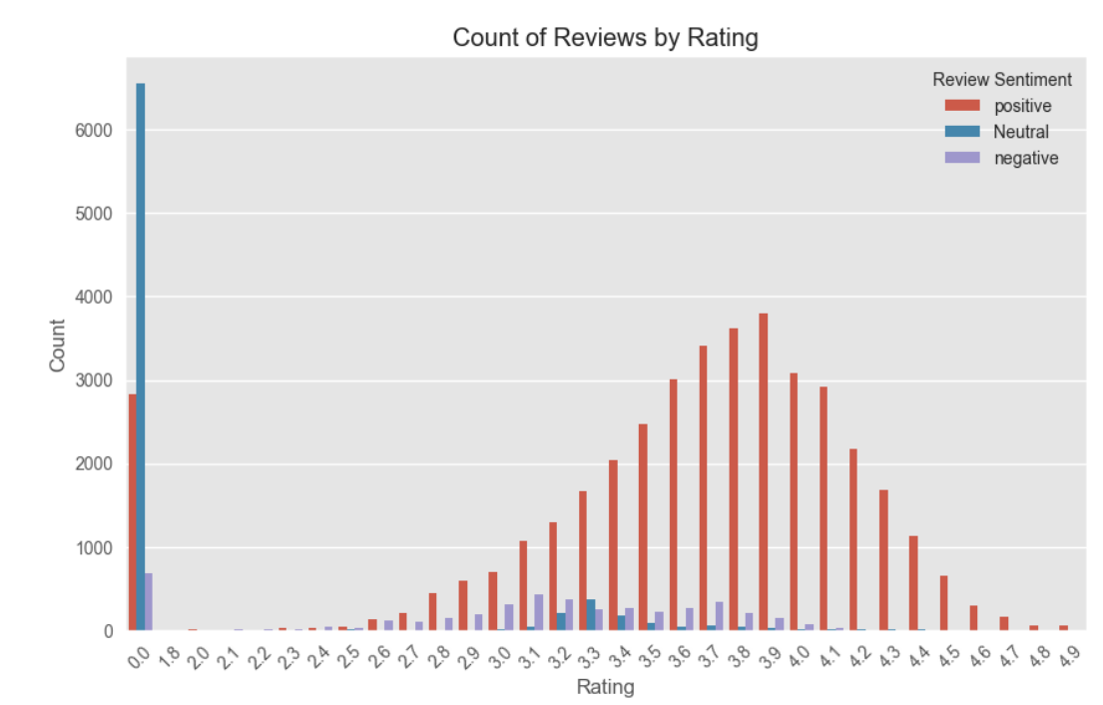

The majority of reviews fall into the positive category, particularly within the mid-to-high rating range (3.5 to 4.5).

A very high number of reviews have a 0.0 rating, which indicates a large amount of dissatisfaction or error in review submissions.

Neutral reviews are the least common across most rating categories, but they also show a spike at the 0.0 rating.

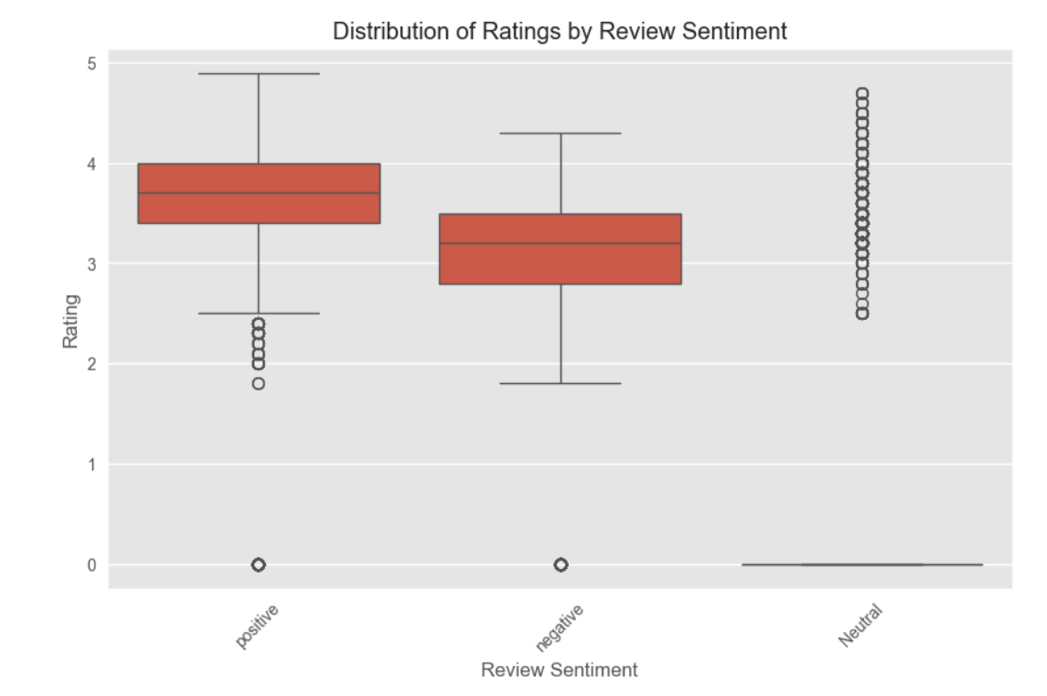

Positive reviews tend to have higher ratings, while negative reviews have a broader distribution but generally lower ratings.

Neutral reviews consistently yield an average rating of 3.

There are more variations and outliers in the positive and negative sentiment categories compared to the neutral category.

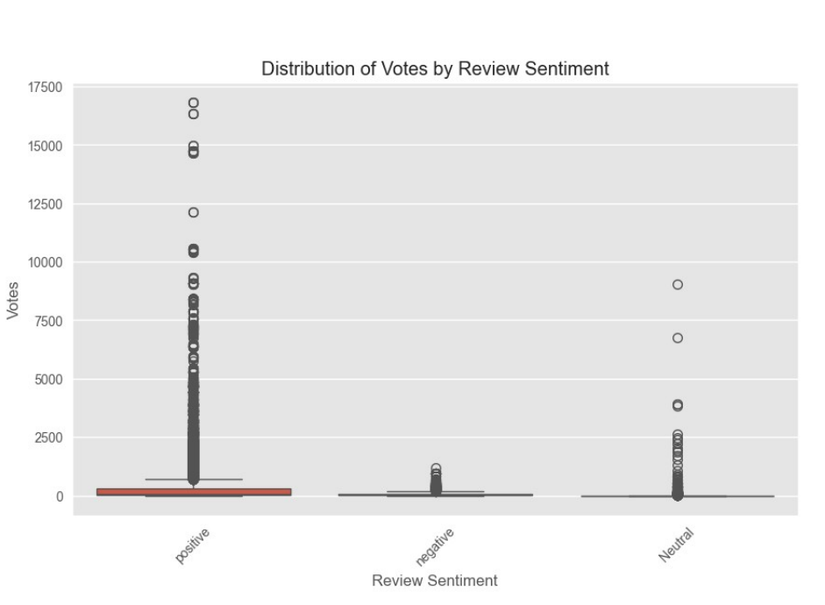

Positive Reviews:

* There is a large spread in the number of votes, with many outliers.
* Most of the data points are concentrated near the lower end, but some reviews have received significantly higher votes.
* The majority of positive reviews have votes less than 2,500, but some outliers reach up to 17,500 votes.

Negative Reviews:

* The distribution is much more condensed compared to positive reviews.
* The votes for negative reviews are generally low, with most falling below 2,500.
* There are some outliers, but they are far fewer and lower in votes compared to positive reviews.

Neutral Reviews:

* Similar to negative reviews, the distribution is more condensed.
* Most neutral reviews have low votes, generally below 2,500.
* There are a few outliers, but they are not as extreme as in positive reviews.

General Observations:

* Positive reviews have the widest range and the highest number of outliers, indicating that they receive a significantly higher number of votes compared to negative and neutral reviews.
* Both negative and neutral reviews have a much more compressed vote distribution, with few outliers.

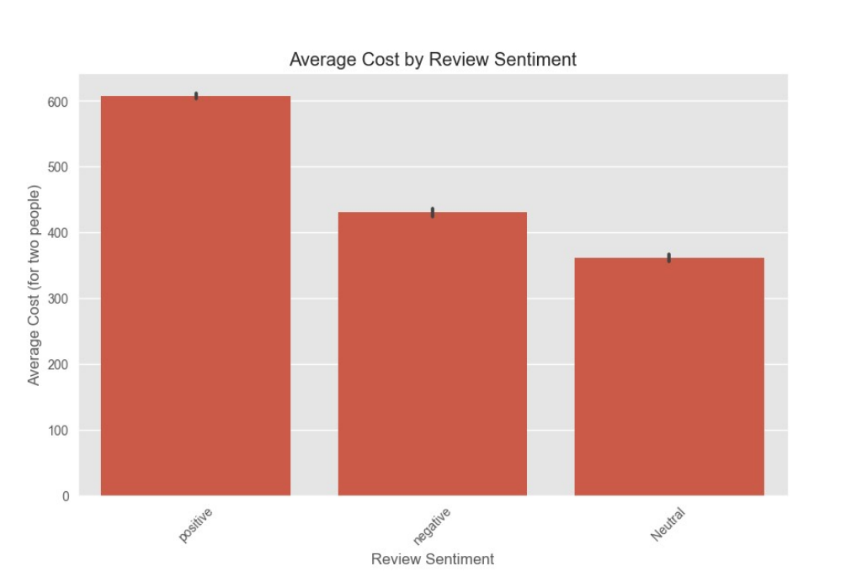

Key Observations:

* Review Sentiments: The x-axis represents three categories of review sentiments: positive, negative, and neutral.
* Average Cost: The y-axis represents the average cost for two people, ranging from 0 to 600.

Positive Reviews:

* The average cost associated with positive reviews is the highest, approximately 600.
* This indicates that more expensive experiences tend to receive positive reviews.

Negative Reviews:

* The average cost associated with negative reviews is lower than positive reviews, approximately 400.
* This suggests that experiences costing around this amount tend to receive negative feedback.

Neutral Reviews:

* The average cost associated with neutral reviews is the lowest, approximately 300.
* This implies that less expensive experiences tend to receive neutral reviews.

General Observations:

* There is a clear trend where higher costs are associated with positive reviews and lower costs with neutral reviews.
* Negative reviews are positioned in the middle range in terms of cost.

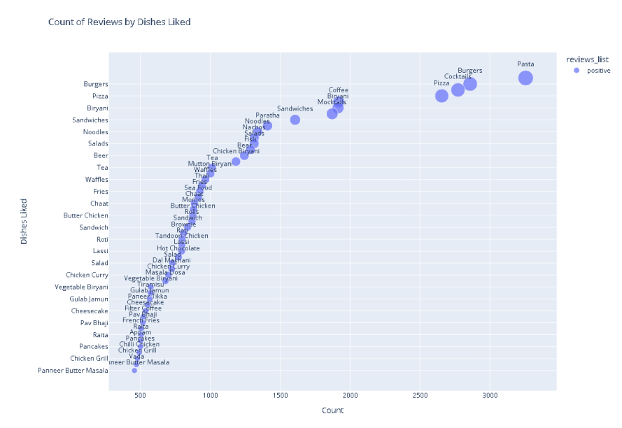

Key Observations:

* Dishes Liked: The y-axis represents different dishes that have been liked.
* Count: The x-axis represents the count of reviews for each dish.
* Positive Reviews: The plot highlights the positive reviews, with the size of the bubbles indicating the number of positive reviews.

Interpretation:

* High Popularity Dishes: Some dishes like Pasta, Burgers, Pizza, and Cocktails have the highest counts of positive reviews, shown by the larger bubbles and their position far to the right on the x-axis.
* Moderately Popular Dishes: There are several dishes like Coffee, Biryani, Sandwiches, and Noodles that have a moderate count of positive reviews, indicated by their intermediate position on the x-axis and medium-sized bubbles.
* Less Popular Dishes: Many dishes such as Tea, Waffles, Fries, Chicken Curry, and Cheesecake have lower counts of positive reviews, represented by smaller bubbles and their position towards the left on the x-axis.

General Trends:

* The scatter plot shows a positive correlation between the number of reviews and the dishes liked, indicating that dishes with higher counts of reviews are generally more liked.
* The size of the bubbles gives a visual representation of how positively each dish is reviewed, with larger bubbles indicating higher positive feedback.

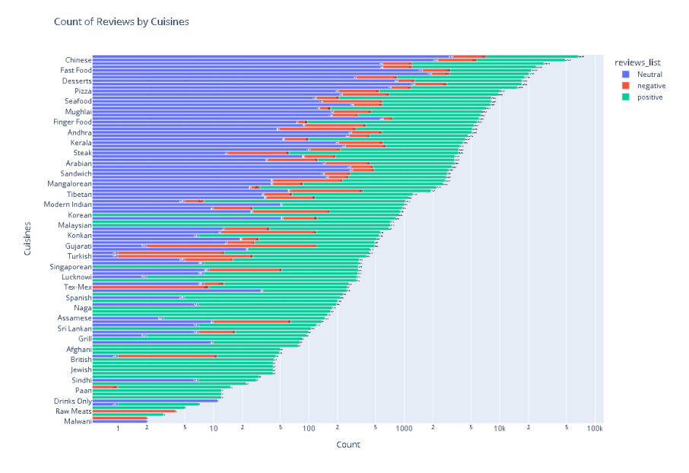

Cuisines with the Most Reviews:

* Chinese cuisine has the highest number of reviews, with a significant portion being positive, followed by neutral and negative reviews.
* Fast Food and Desserts also have a high number of reviews, with a similar distribution of sentiments.
* Other cuisines like Pizza, Seafood, Mughlai, and Finger Food follow with fewer reviews but still have a considerable count.

Cuisines with Moderate Reviews:

* Cuisines like Andhra, South Indian, and Rajasthani have a moderate number of reviews. The sentiment distribution shows a predominant number of positive reviews, with fewer neutral and negative reviews.

Cuisines with Few Reviews:

* Cuisines like Pan, Drinks Only, Raw Meats, and Malwani have the least number of reviews. These cuisines show a similar sentiment distribution but on a much smaller scale.

Sentiment Distribution:

* Most cuisines have a larger proportion of positive reviews (blue), followed by neutral (gray) and negative (red) reviews.
* This pattern is consistent across all cuisines, indicating that generally, more people tend to leave positive reviews compared to neutral or negative ones.

Review Counts:

* The review counts span from single digits to over 100,000. The scale on the x-axis is logarithmic, which means the difference between each tick mark increases exponentially.

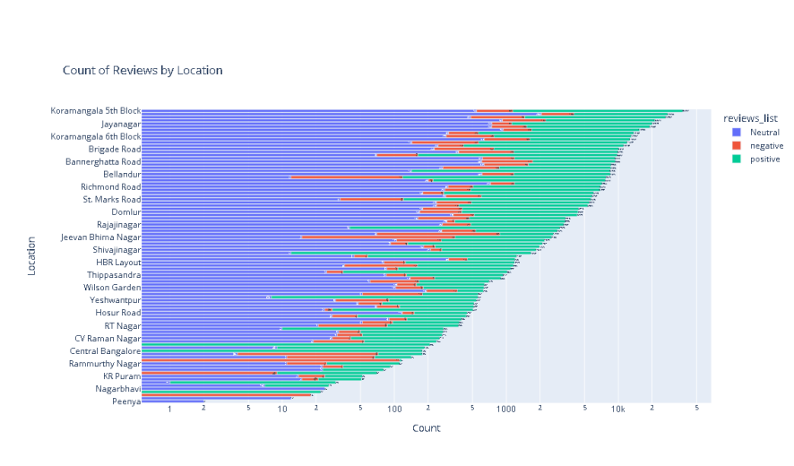

Locations with the Most Reviews:

* Koramangala 5th Block has the highest number of reviews, with a significant portion being positive, followed by neutral and negative reviews.
* Jayanagar and Koramangala 4th Block also have a high number of reviews, with a similar distribution of sentiments.
* Other locations like Brigade Road, BTM, and Indiranagar follow with fewer reviews but still have a considerable count.

Locations with Moderate Reviews:

* Locations like Marathahalli, Whitefield, and Frazer Town have a moderate number of reviews. The sentiment distribution shows a predominant number of positive reviews, with fewer neutral and negative reviews.

Locations with Few Reviews:

* Locations like RT Nagar, Ramamurthy Nagar, and Peenya have the least number of reviews. These locations show a similar sentiment distribution but on a much smaller scale.

Sentiment Distribution:

* Most locations have a larger proportion of positive reviews (blue), followed by neutral (gray) and negative (red) reviews.
* This pattern is consistent across all locations, indicating that generally, more people tend to leave positive reviews compared to neutral or negative ones.

Review Counts:

* The review counts span from single digits to over 50,000. The scale on the x-axis is logarithmic, which means the difference between each tick mark increases exponentially.